Inroduction to IoT

IIIT Naya Raipur, Chattishgarh, India.

Yash Ghodekar (CSE)  
201000059  
yash20100@iiitnr.edu.in

Kshitij Kumar Singh Chauhan (CSE)  
201000022  
kshitij20100@iiitnr.edu.in Swarup Yeole (CSE)  
201000054  
swarup20100@iiitnr.edu.in

Revant Sri Emany (CSE)  
201000042  
revant20100@iiitnr.edu.in

Abstract

Nowadays, own safety has turned out to be a noteworthy problem for everybody, but especially for women. A recent survey made by UN showed Ninety percent of women, in Delhi, do not feel all safe in public places [1]. The tally of victims is steadily growing and not just women even the vulnerable sections of society like small children and even elderly find themselves in a situation where they are subjected to physical abuse, in order to tackle this here we propose a system which focuses on safety of the vulnerable along with other multi-functionalities that it offers. The project idea is to provide a swift responding and reporting safety device for anyone who requires help. The core of the methodology adopted to serve the aforementioned purpose relies on timely alerts to seek the required vigilance. This device makes it possible at the press of a button. Whenever in danger, various data such as location, pulse rate can be sent via SMS to designated numbers number by using the GSM through Arduino UNO. It can be used as a smart fitness band in daily lives which displays all the vital health information and time and when required it acts as a safety device. The device is quite accurate and can work on even 2G SIM.

# **Introduction**

Women safety has become a prominent issue all over the world. In India only, the crime rate against women has increased rapidly in last few years. According to NCRB (National Crime Records bureau) report published in October 2017, 55.2 percent crime rate against women was reported [2]. In today's technical world, many gadgets and applications are being developed in this direction. Specifically, IoT has played an important role to secure the women with its advanced devices and applications. The only answer to the problem can be taken in a such a way that, women should be assigned with a safety gadget that is portable and ensures her safety. Our project focuses on providing a Smart gadget based on IoT solutions.

Many existing applications send custom message to emergency numbers to trace the current location of victim. Alternatively, numerous IoT devices use sensors to optimize body parameters that can directly send alarming message to guardians or women helpline. Although, there exists code like “*91 #”, in India that can be used to provide emergency services but there may be a situation where the girl is not capable of dialling the code. There are many such software applications and smart gadgets adopted to restrain the crimes against women with the help of smart phones or with wearable devices but they are in “not sufficiently efficient” in this regard.

Existing systems are bulky and are not portable where in these cannot be carried easily anywhere, any time. They require more hardware, which in turn increases the implementation cost. The systems don’t provide a complete kit solution to the existing problem. Most of the systems provide solutions in pieces and are separated with each other thereby lacking the feature of one stop solution to problem of women safety. So the emphasis is to build a solution that works autonomously in situations encountered. Also, these existing technologies are non-productive when not being used as a safety device.

* Location is one of the important and dominant features that needs to be taken care into account. Identifying, simulating as well as processing the exact Global Positioning System (GPS) coordinates of any type of the misconduct and unlawful act allows the police department and concerned person to give fast mediation in critical crime situations.
* Prototype proposed in this paper allows user to trigger alerts via GSM module, at the press of a button.
* Our prototype also checks false alerts and manhandling by buffer-time delay and ultrasonic sensor respectively.
* In addition, it also tracks vital; health parameters like temperature and pulse rate.

# **Objectives**

This paper primarily focuses on following

objectives :

1. Designing a methodology to swiftly trigger safety alerts, simultaneously checking for false alerts.
2. To add versatility to the prototype by adding elements of health monitoring to its functionality.

# **Proposed Methodology**

## **Theory of Operation For Prototype**

The device can be activated by just pressing the emergency button for the alert purpose. The method which works behind this is as explained below:

This smart device (based on IoT) which includes a GPS modem, is activated by retrieving its location based on its longitude and latitude, is fed to the Arduino UNO, which retrieves the location details of the device from GSM and it triggers in the form of a text message. Between these steps of retrieval of data and sending alert message, it gives a buffer time of three seconds, which allow user to cancel the alert, in case it was not intended by merely pressing the button again.

Following components have been used to design the prototype:

1. **Sensors:**

a. For the purpose of safety:

i. GPS receiver module

ii. Ultrasonic sensor

b. For the purpose of health monitoring:

i. Temperature sensor

ii. Pulse rate sensor

2. **Microcontroller:**

ATmega328P

3. **Communication Module:**

GSM Module (SIM800L)

4. **Mobile Interface:**

a. Messaging App

b. Google Maps

5. **Data Format:**

a. GPS Coordinates (Latitude & Longitude)

b. SMS (Text)

6. **Cloud:**

Thing Speak (to store health parameters for analysis, visualisation, and reference)

Following methodology has been adapted in this prototype:

**Sensing:**

**a. Panic button:** Panic button can be used to trigger alert when in danger.

**b. GPS Receiver:** GPS receiver retrieves geo-coordinates, i.e., latitude and longitude of the user.

**c. Ultrasonic sensor:** Ultrasonic sensor checks manhandling of device and triggers an alert if device is detached against will. It allows user to cancel the alert within three seconds, by pressing panic button in the allotted buffer time if an alert was not intended.

**d. Temperature sensor:** Temperature sensor aids in monitoring temperature of the user.

**e. Pulse rate sensor:** Pulse rate sensor aids in tracking pulse rate of user over time.

**Communication:** GSM module has been used to send the alert messages to pre-set mobile numbers and to push data to the cloud.

**Cloud:** Data acquired by temperature sensor and pulse rate sensor is transferred to things speak cloud. Data is thereafter analysed for meaningful inference as and when required.

**Interface:**

**a. Messaging App:** Massaging app allows user to received alert message.

**b. Google Maps:** Services of google maps have been utilised to present raw geo-coordinates in a comprehendible form.

Apart from being a safety device, this prototype also functions as a health monitoring system, when not being used for former purpose, thereby adding on to its versatility. Though, primarily designed for women, this device is flexible enough to be used by children or any one in need.

## **Sensor node diagram**

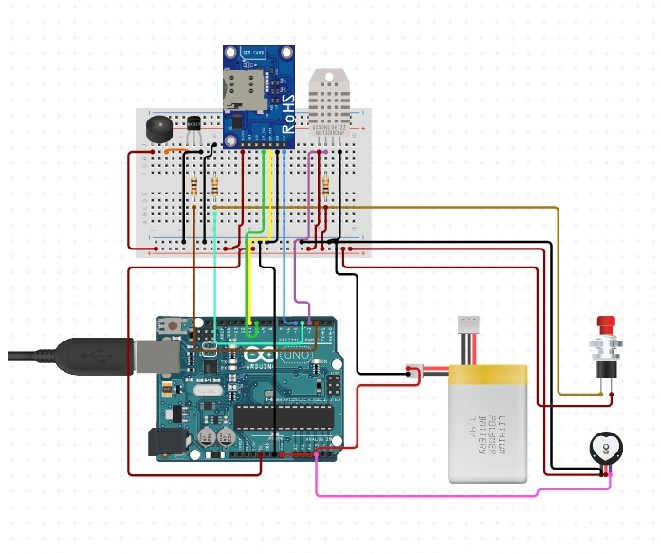

*Fig 1 : Sensor node diagram*

This sensor node includes following components:

• **Arduino Uno (microcontroller ATmega328P):** establishes control and coordination between individual entities of prototype.

• **Push button:** Initiates alert triggering system

• **Ultrasonic Sensor:** Checks distance between user (hand) and device (When device is switched on)

• **Quadband GPRS-GSM SIM800L:** SIM800L is a small quad-band GSM/GPRS module, equipped with quad-band antenna

**• Buzzer:** For implementation of buffer time

• **Temperature sensor:** to monitor user temperature

• **Pulse rate sensor:** to track pulse rate of user

## **Algorithm**

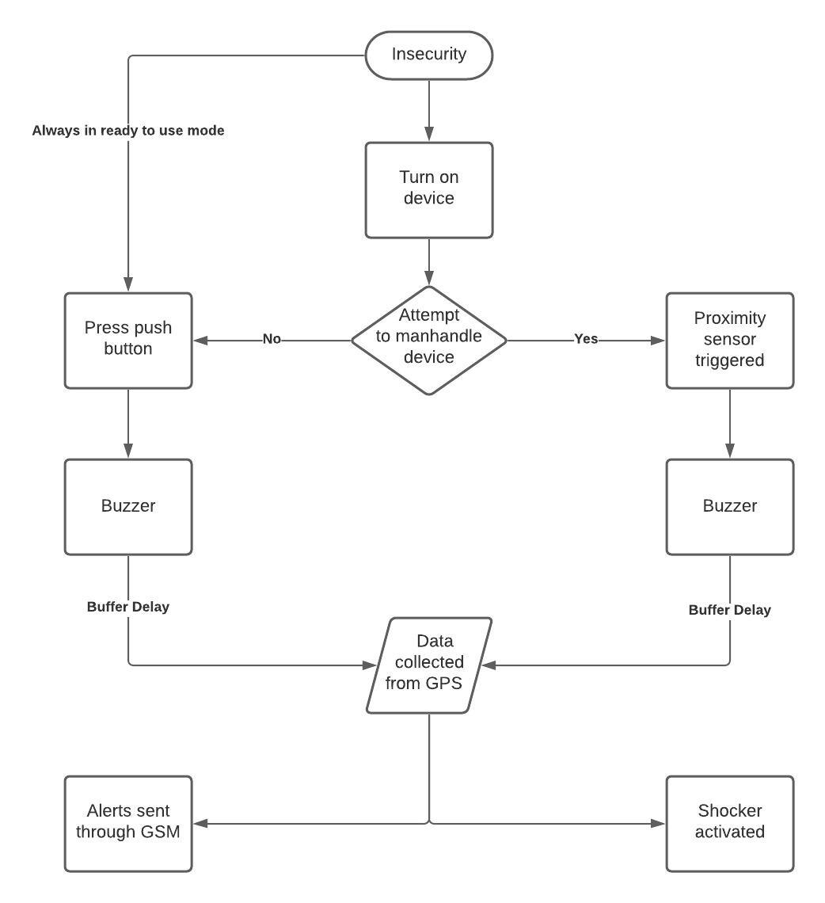

*Fig 4 : Algorithm in use*

## **Block Diagram**

*Fig 3 : Block diagram of prototype*

1. Once alert triggering procedure is initiated, buzzer beeps for a buffer time (three seconds) allowing user to cancel the alert, if triggered unknowingly.
2. If the procedure is not cancelled in buffer time, then location (latitude, longitude) is transferred to set mobile numbers using GSM module.
3. User on the other end receives the location coordinates as a message. Google maps can be used to make it more comprehendible.

Lithium-ion battery has been used to power the prototype.

## **Conceptual Diagram**

1. Pressing panic button (Manual trigger)

2. Using proximity sensor (Checks manhandling of the device)

Once, an alert has been triggered, location data accessed using GPS is transferred with an alert message to pre-set numbers via GSM module. Google maps aid in accessing the geo-coordinates, i.e., latitude and longitude obtained from GPS in a comprehensible form.

It also offers additional functionality of health monitoring via temperature and pulse rate sensors.

# **Results and Analysis**

## **Overview of Results:**

Developed model is a security gadget which works with DC power supply of five volts; sensors on device will start taking readings of heart beat sensor and temperature sensor. These readings are continuously sent to Arduino UNO. Microcontroller Atmega328p of Arduino UNO prints these readings on LCD display and these readings are further pushed to cloud via GSM module. If, at any point of time, panic button is pressed Arduino UNO sends alert message after a buffer delay of three seconds identified by buzzer sound. If panic button is pressed yet again during the buffer delay, then alert message gets cancelled and false alert is eliminated. Similar procedure initiates while triggering message via ultrasonic sensor. GPS is installed in device to continuously track the user. Using IoT platform Things speak one can also track the health parameters of victim or even in general, medical consultants can continuously monitor changes in sensors values. The above-mentioned operations are successfully validated and successful results are obtained.

## **Sample Snapshots**

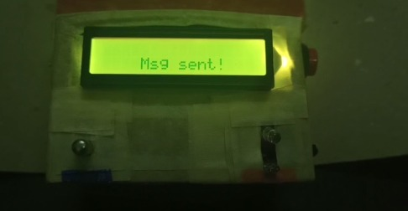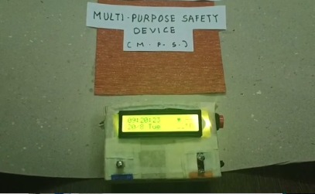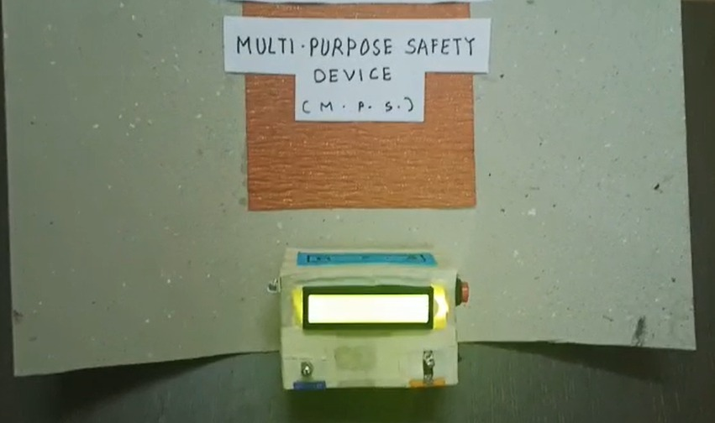

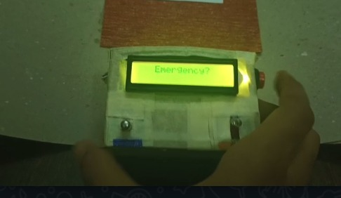

## **C. Critical appraisal and future prospects**

This Project proposed the system for security of women with the help of the wireless method which will communicate and alert the messages sent to the predefined number with the secure medium. The project is to ensure security for the women by providing automatic sensing of problems, threats and sends help messages and position of the victim to the relatives and nearby police station using Internet of Things.

But amidst all its constructive contributions it lacks on certain aspects. At present prototype does not provide information of culprit. The concern was noted during acquisition of results while testing of prototype under varying conditions.

We suggest to shift this project to Raspberry pi in future so that when the button in the band is pressed camera will automatically capture the images and it will collect the information of the culprit. The SMS will be sent to the pre-set numbers along with the captured image link. This will aid in investigation, that eventually by its virtue, would be able to yield more timely and concrete results.

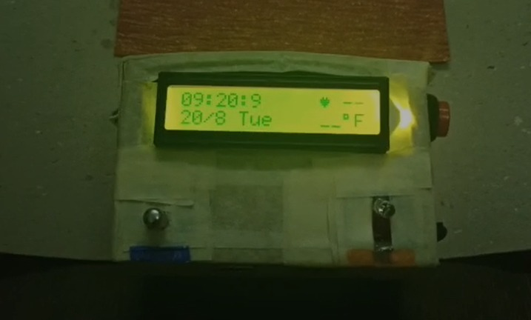

**Comparison with existing methodologies**

The authors **[3]** have worked on the use of the Internet of Things (IoT) that leads to smart security technology. He has highlighted the development of a security device called Smart Band that communicates with a smart phone that has access to the Internet, alerting the victim's family, friends and police about the incident, which is assisted by GPS tracking and messaging services. Our prototype has improved on this work by eliminating the use of internet, which may be troublesome at times of poor connectivity.

Authors of **[4]**have developed a smart security device based on IoT concept. Throwing light on social challenges faced by women, a device called “watch me” has been proposed that includes a sensor to perceive the heart beat rate of a person that will become high when the woman is in danger, making an alarm sound to grab the attention of nearby people. The device also automatically makes a call to registered contacts and supports GPS tracking to track the victim's location. This device was susceptible to to inaccurate alerts and also lacked any reliable mechanism to check it. With the introduction of buffer time delay our device resolves aforesaid issues

The Nirbhaya-be fearless app, **[5]** is another app that helps the user in sending SMSs alert or call with a single touch in the event of an emergency. When the shake alert of app is activated, it sends victim's precise and accurate GPS location to pre-selected contacts from their contact list. However, app does not help in the case when manual trigger of alert is not feasible. Our prototype resolves this issue largely using ultrasonic sensor.

None of the existing methodology, mentioned above, remains functional when not being used a safety device. Our prototype, however, can also be used as health monitoring band thereby adding to its worthiness.

**CONCLUSION**

Our effort behind the project is to design a gadget which is reliable, conveniently portable, and swift in action. It is cost-efficient, fast and works without using the internet or any smartphone.. The cost of this application is very less in comparison to other applications in the market. Furthermore, it is also flexible enough to be used as health monitoring device. It provides complete safety solution and inching closer to the goal of creating a safer world. It has been designed for mainly women’s security purposes but also could be used for aged citizens and children. In the future, this device will be more user-friendly by scaling this device’s size. Besides, more advanced technology will be used for implementation to optimize the performance of this device.

**Acknowledgment**

At the outset, we would like to express our wholehearted and deep sense of gratitude to our guide, Prof. Venkanna U. for his guidance, help and encouragement throughout our project work. We grateful for his guidance in research, creative thinking, hard work and dedication in work.. This project would not have been possible without his bounteous efforts. More than a guide, he is our mentor for shaping our personal and professional life, without whom we would not have been where we are today. We owe our profound gratitude to him for his support in all respects.

##### **Learning Outcomes**

Following learning outcomes were achieved in the due course of the project :

1. Results obtained showed 100% accuracy in cancelling alerts that were triggered by mistake. This was a key outcome as this would help minimize the issue of false alerts that had been there in earlier methodologies.

2. Health parameters were pushed to cloud for visualization and analysis. We were able to keep record of the same for future references. This would help revolutionize virtual medical consultancy.

3. We were also able to push current location to cloud. In future proposals, using better equipped sensors live tracking can be implemented into th project

4. Comparative analysis of various sensors catering to similar need of proximity check and selection of ultrasonic sensor, of them, owing to its effectivity in context of the problem

5. Analysis of pros and cons of various communication modules for the prototype and selection of GSM module, of them, owing to its reliability and range, unlike other modules that require internet connectivity.

##### **References**

1. UN, Delhi survey UN Women supported survey in Delhi shows 95 per cent of women and girls feel unsafe in public spaces – Office of the Secretary-General’s Envoy on Youth
2. National Crime Records Bureau, Stat Publication https://www.ncrb.gov.in/StatPublications/CII/CII2016/pdfs/NEWPDFs/CrimeinIndia-2016CompletePDF291117.pdf
3. Thavil, J. K., V. P. Durdhawale, and P. S. Elake. "Study on Smart Security Technology for Women based on IOT." International Research Journal of Engineering and Technology (IRJET) 4.02 (2017).
4. Runyan CW, Bangdiwala SI, Linzer MA, et al. Risk factors for fatal residential fires. N Engl Med J 1992;327:859–63.
5. Helen, A., et al. "A smart watch for women security based on iot concept ‘watch me’." 2017 2nd International Conference on Computing and Communications Technologies (ICCCT). IEEE, 2017.